UAV Detection using YOLO metrics

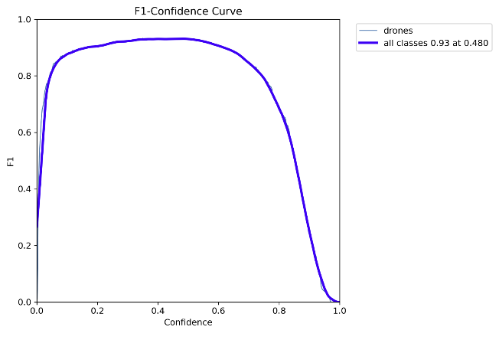

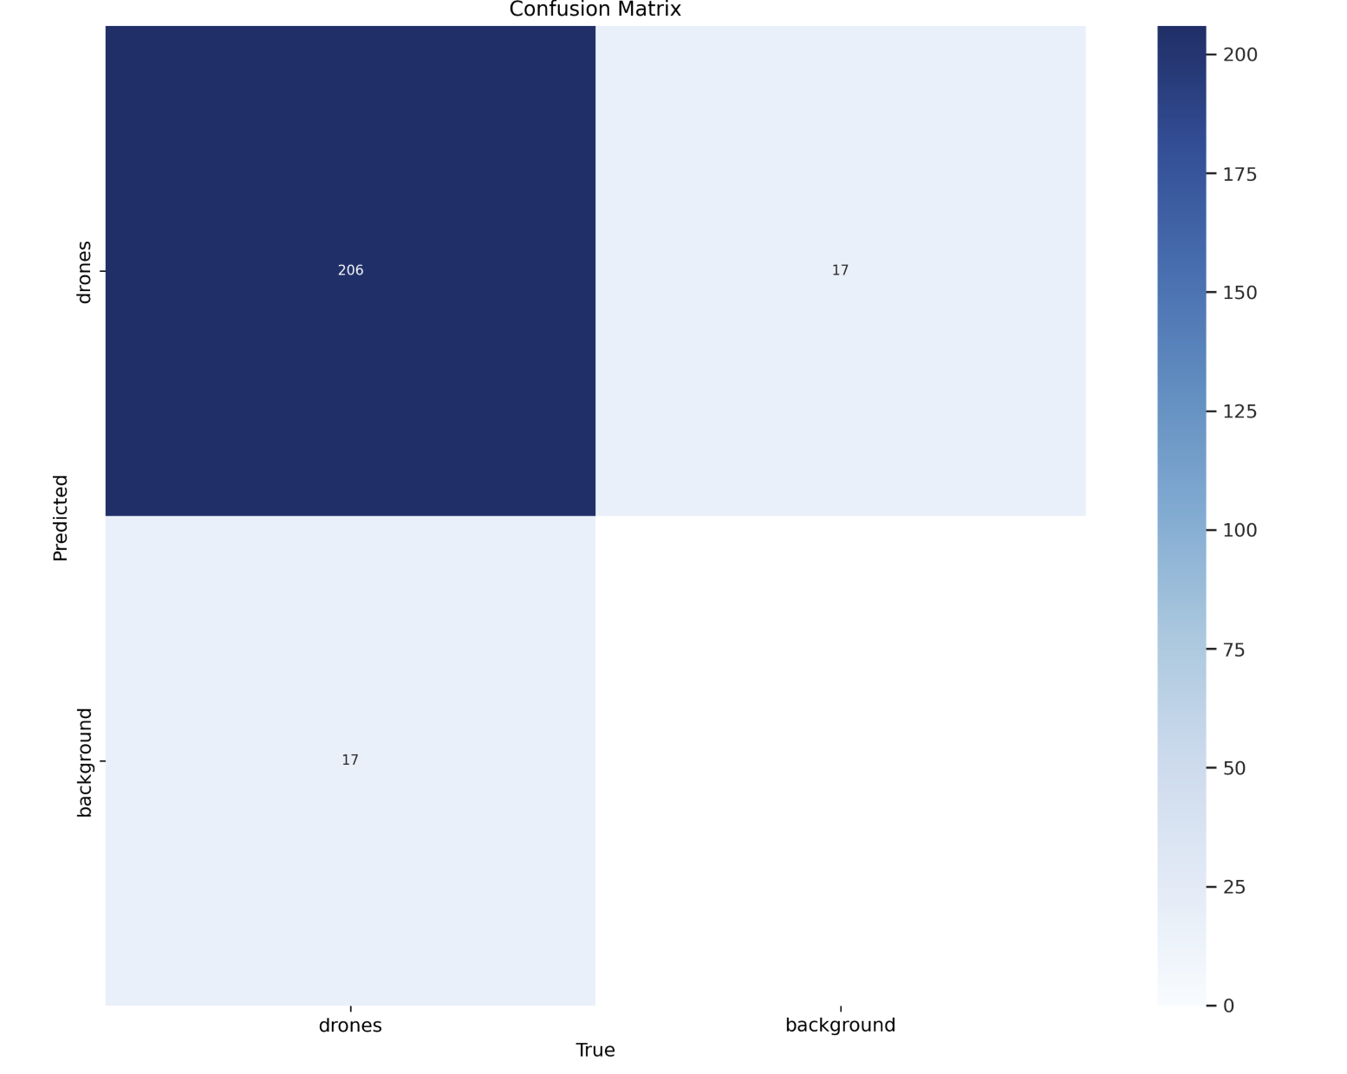

Prediction on a test image

Prediction on a video

